**Laboratory work 4**

**Determining and removing drawbacks of exponential and running mean**

Objective: To determine conditions for which broadly used methods of running and exponential mean provide effective solution and conditions under which they break down.

This report consists of two parts:

1. Drawbacks of running mean (2 trajectories)
2. Comparison of the traditional 13-month running mean with the forward-backward exponential smoothing for approximation of 11-year sunspot cycle.

1a) Analyzing of a process which rate of change is changed insignificantly and measurement noise is great.

We generated a true trajectory $X_{i}$ of an object motion disturbed by normally distributed random acceleration

$$X_{i}=X_{i-1}+V_{i}T+\frac{a_{i}T^{2}}{2}$$

$$V_{i}=V_{i-1}+a_{i}T$$

Where:

Size of trajectory is 300 points.

Initial conditions: $X_{1}=5;V_{1}=0;T=0.1$

Variance of noise $a_{i}$, $σ_{a}^{2}=10$

We generate measurements $z_{i}$ of the process $X_{i}$

$$z_{i}=X_{i}+η_{i}$$

Where:

$η_{i}$–normally distributed random noise with zero mathematical expectation   
and variance $σ_{η}^{2}=500$.

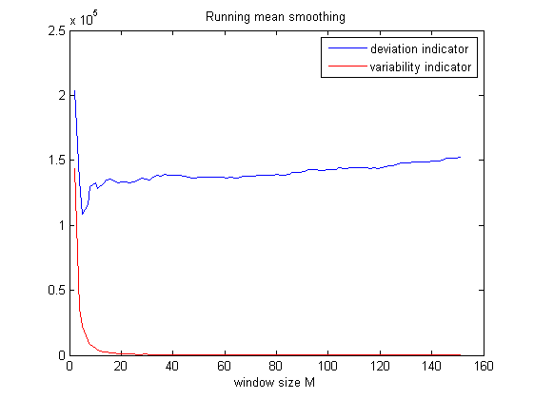The dependences of deviation and variability indicators on window size of running mean M and smoothing coefficient $α$ were analyzed. The results are shown below:

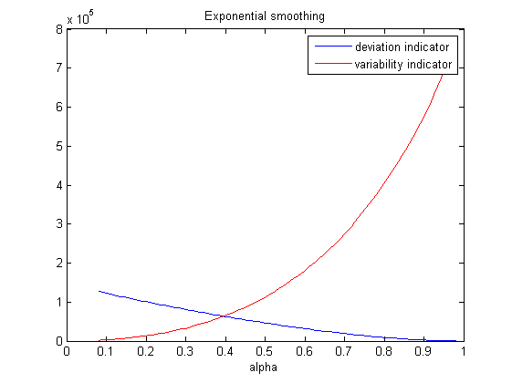

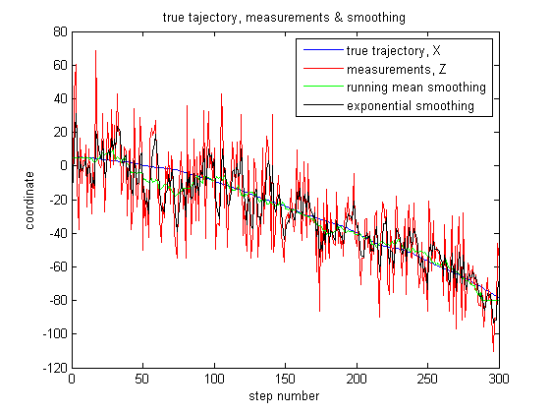The optimal window size of running mean M and smoothing coefficient $α$ are approximately m=25, alpha=0.4. However, exponential smoothing looks better, because deviation indicator is twice less, than for running mean smoothing (in best conditions). True trajectory, measurements and different smoothing are shown below. Exponential smoothing fits measurements very good.

1b) Secondly, we studied a cyclic process and measurement where noise is small.

We generated cyclic trajectory $X_{i}$ according to the equation

$$X_{i}=A_{i}⋅sin⁡(ωi+3)$$

$$A_{i}=A_{i-1}+w_{i}$$

Where:

Periods of oscillations is T=32 steps.

$w_{i}$– normally distributed random noise with zero mathematical expectation   
and variance $σ_{w}^{2}={0.08}^{2}$.

Size of trajectory is 200 points.

Initial conditions: $A_{1}=1$.

We generated measurements $z_{i}$ of the process $X_{i}$

$$z_{i}=X_{i}+η_{i}$$

Where:

$η_{i}$–normally distributed random noise with zero mathematical expectation   
and variance $σ_{η}^{2}=0.05$

We applied running mean with window size $M=13$ to measurements $z_{i}$. The results are shown below:

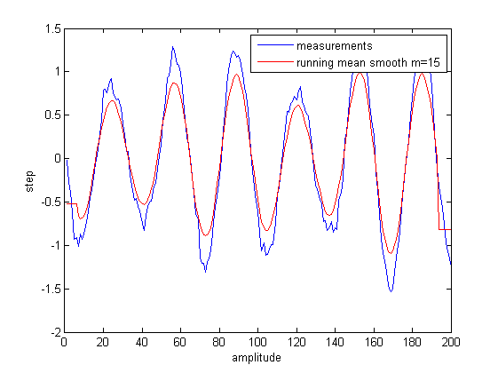

The periods of oscillations for which running mean for $M=15$ were determined:

1. inverse oscillations T=12

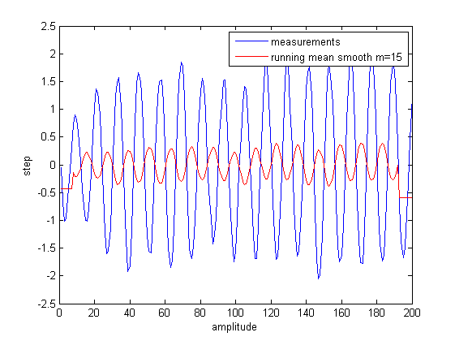

1. the loss of oscillations (zero oscillations) T=5

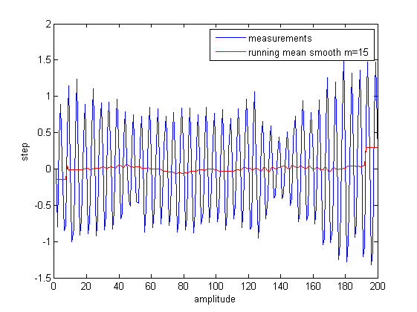

1. Changing the oscillations insignificantly T=40

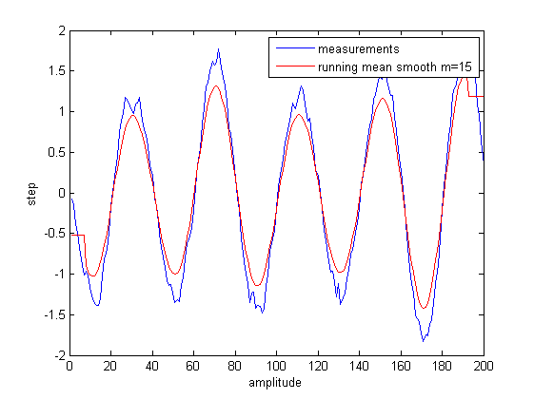

Part III:  
Comparison of the traditional 13-month running mean with the forward-backward exponential smoothing for approximation of 11-year sunspot cycle

Monthly mean sunspot number and solar flux were downloaded:

Group 1: data_group1.mat

13-month running mean $\overline{R}$ was applied:

$$\overline{R}=\frac{1}{24}R_{i-6}+\frac{1}{12}{(R}_{i-5}+R_{i-4}+…+R_{i-1}+R_{i}+R_{i+1}+…+R_{i+5})+\frac{1}{24}R_{i+6}$$

Then forward-backward exponential smoothing of monthly mean sunspot number and flux were made. The results are shown below:

For running mean indicators are constant:

Deviation indicator for flux =1.7*10^5

Deviation indicator for sunspot =4*10^5

Variable indicator for flux = 4.1*10^3

Variable indicator for sunspot = 7.8*10^3

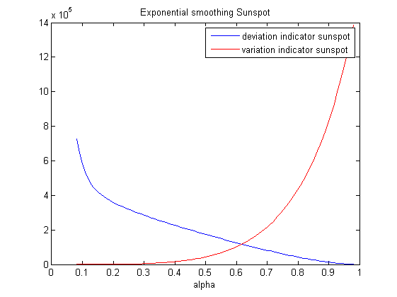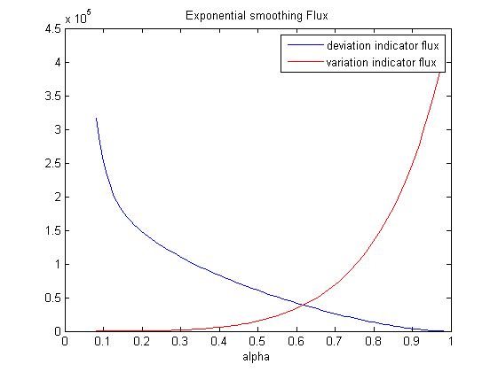

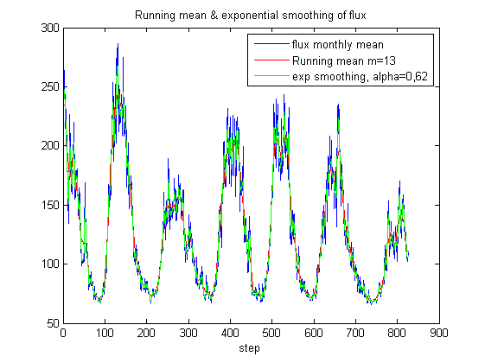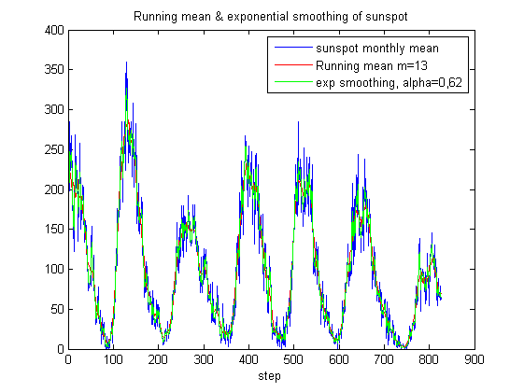

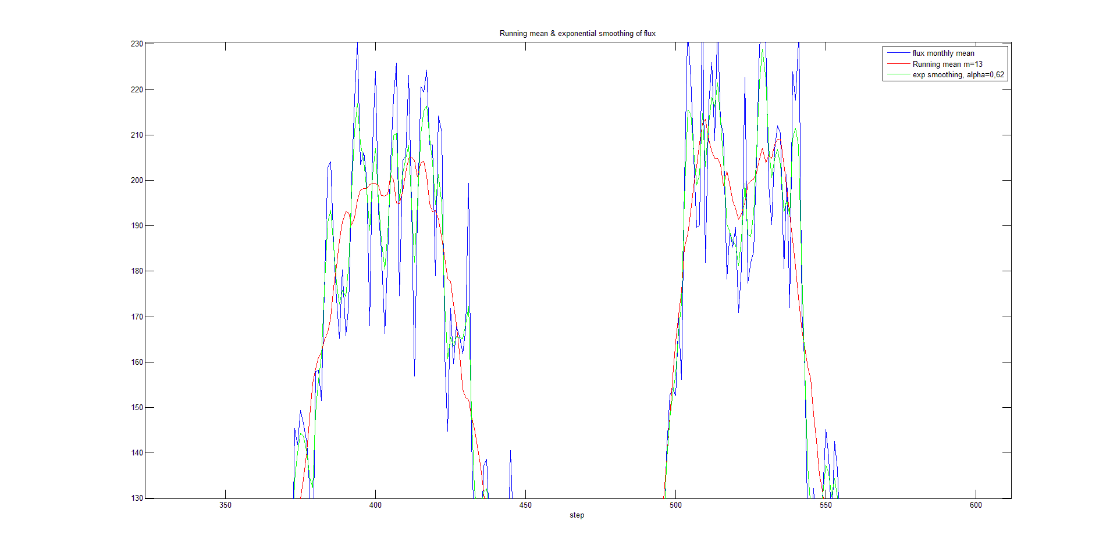

For $α=0.62$ (intersection) deviation and variability indicators are less (approx. 1.5*10^5) that deviation and variability indicators for running mean smoothing of sunspot and flux. So, for value of $α=0.62$

exponential smoothing is better.